20 subject in each condition: backward (b), forward (f), random/control (r)

1. Average for each participant separated by correct rejection and hits

1. Average probability of correct separated by probetype

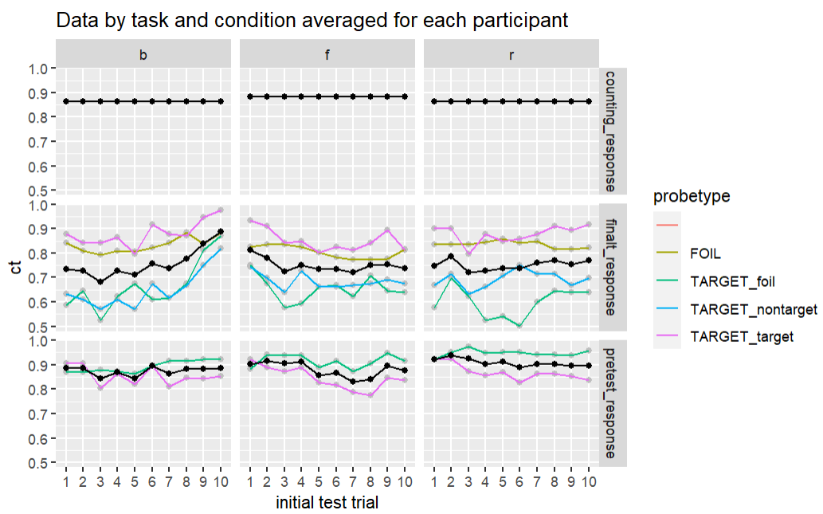

1. Conditional probability correct of post test based on pretest response

1. Serial position curve of post test by initial test & study position



